Program tutorial Research School Political History
Amsterdam, 11 February 2022

Theme: Sources and Digital humanities.

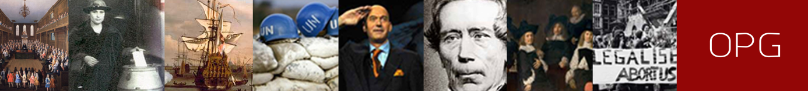

Time: 11 February 2022, 13.00 – 16.30 hrs.
Location: Huygens Instituut voor Nederlandse Geschiedenis (t.b.c.)
(www.huygens.knaw.nl)

Huygens ING is the leading research institute in the field of history and culture. Our research comprises several themes, such as Government of the Netherlands, Debate Culture, Renewal of Editorial methods and Impact of Circulation. The mission of Huygens ING is Back to the source: history unravelled with new technology. We aim to achieve this by inspiring research and by the creation of innovative tools to access, comprehend and analyse historical and inaccessible sources. We do this in the fields of History, Literature, History of Science and Digital Humanities

Organization: Marijke van Faassen (Huygens ING)

Program

12.45 Coffee and tea
13.00 Welcome and opening
13.10 Combining analogue and digital sources in research.
Marijke van Faassen: introduction to the case: International Migration and Technocracy, the Dutch case
13.20 Marijn Koolen and Rik Hoekstra: Using ‘data scopes’ in research (case: Technocracy)
13.45 Q&A and Discussion
14.00 Break (coffee/tea)
14.15 Dialogues on the papers (and the literature)
During this session certain aspects of the papers will be analysed in couples or clusters, followed by a plenary discussion.
16.00 Rounding up
16.30 Closure

Requirements

Paper: 750-1000 words
To prepare the tutorial, you are requested to write a text of 750-1000 words in which you describe the digital and ‘paper’ sources you use to answer your main research question. Please use the required literature and note that the article on Data scopes explicitly is about combining analogue and digital research methods and sources, and is relevant for either type of research.

Please reflect in your paper on the following questions:
- Where do you find your main sources and how do you cope with problems of accessibility (are there alternatives)?
- What are the advantages and disadvantages of the sources you use?
- What kind of information (or data) do you expect to be able to extract from your sources?
- Where do you expect your sources to have shortcomings and how will you remedy these?
- How do you plan to organize the sources and data you gather during your research and keep it accessible in order to facilitate your analysis and writing?

Submit your paper before 1 february 2022 to bureau@onderzoekschoolpolitiekegeschiedenis.nl

On Monday 7 february 2022 we will ask you to prepare some feedback on one of the papers of your fellow PhD’s.

Required reading

- Hoekstra, R. and Koolen, M., 2018. Datascopes for digital History Research. Historical Methods. A Journal of Quantitative and interdisciplinary History, 2, pp.1-16 https://www.researchgate.net/publication/328982105_Data_scopes_for_digital_history_research
- C. Jeurgens, 2013. ‘The Scent of the Digital Archive: Dilemmas with Archive Digitisation’,
BMGN - Low Countries Historical Review, 128 (2013) 30–54.
https://bmgn-lchr.nl/article/view/URN%3ANBN%3ANL%3AUI%3A10-1-110021

Recommended reading
- Z. Tufekci, 2017. Twitter and Tear Gas. The power and fragility of networked protest (Yale University Press, New Haven / London) (e.g. preface, introduction and epilogue)
https://www.twitterandteargas.org/downloads/twitter-and-tear-gas-by-zeynep-tufekci.pdf

Speakers

- Dr. Marijke van Faassen is senior researcher at Huygens ING. Her research focuses on the political-institutional history of the Netherlands, International Relations as well as migration history.
- Dr. Rik Hoekstra is digital historian at Huygens ING. His research focuses on early modern socio-political issues and digital research methodology.
- Dr. Marijn Koolen is information scientist at Huygens ING. His research focuses on information retrieval, information behaviour and digital humanities.

