First announcement
Summer School for Research Masters 2017
In search of the political in culture. Representation, inclusion and exclusion

Date: 26 June – 30 June 2017
Credits: 5 ECTS (with additional tasks 6 ECTS)
Organization: Research School Political History , in cooperation with prof. dr. Susan Legêne
(VU Amsterdam)
Registration : before 1 February 2017 (bureau@onderzoekschoolpolitiekegeschiedenis.nl)

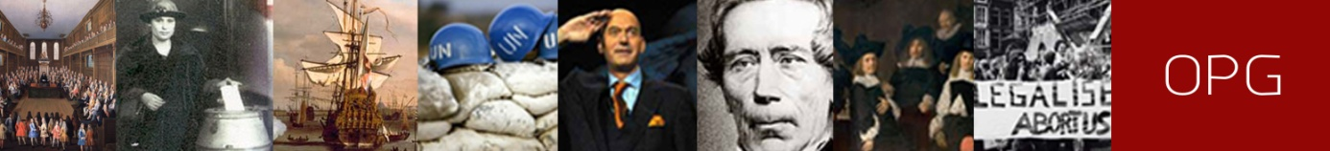

Representation
In recent years, the concept of representation has become more and more important in political history, political thought and cultural analysis. It deals with questions like what is representation in parliamentary politics, who is visible in historical narratives, what and who are excluded. In this Summer School we will focus on historical and cultural approaches to representation, inclusion and exclusion. We examine the concept from different perspectives and challenge the participants to connect this to different disciplines (history, cultural studies, political science, and postcolonial perspectives). Special attention will be paid to the work of Frank Ankersmit and Stuart Hall.

Aims and added value
The aim of the Summer School is to develop insight and research skills in political history: to formulate a research question and a research strategy, and execute an analysis of primary sources as the basis for writing a research report. Students acquire skills and insight in the use of specific methods and approaches of political history, e.g. comparative history, institutional analysis, discourse analysis, biography. A substantial part of the course will be devoted to practical training, like critical approaches to archives, oral history and uses of material culture as historical source. Students develop insight in specific themes under the supervision of experts at the cross roads of political history, cultural history and philosophy, and present their own research.
Added value is the networking opportunities with staff and other students. If you consider writing a PhD, it is recommended to attend the Summer School.

Requirements
Position paper: Before the beginning of the course, each participant hands in a position paper, in which the assigned literature is discussed and related to your own research.
Presentation: During the Summer School, the participants prepare a presentation of the outline of their research paper.
Research paper: After the end of the Summer School, each student writes a research paper of 5000 words (6 ECTS: 6500 words). This paper is a further elaboration of your preliminary finding presented in your presentation, and has to be based on additional reading material.

